To check whether your child’s school uses the booking feature, select the child you wish to view. The bookings option will be available on the child's information screen 'Book meals and places'.
Making bookings
- Login to www.parentpay.com
- Select Book meals and places for the person you wish to make the booking for.
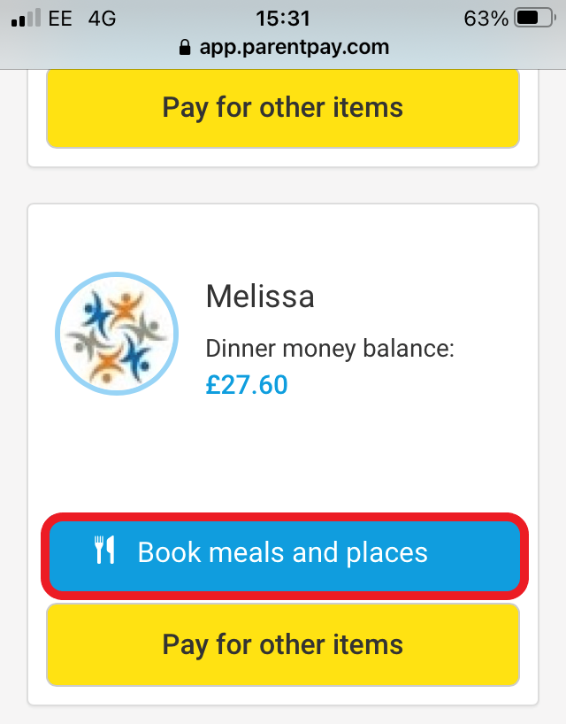
- Select the time of day that you wish to make a booking for.
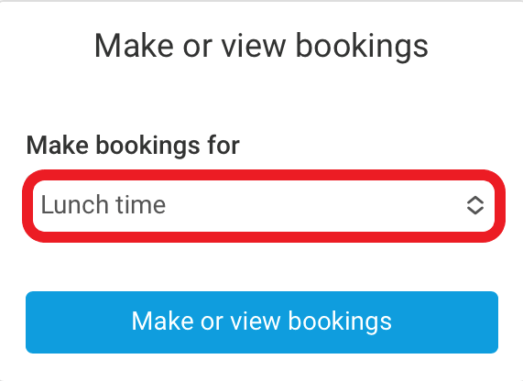
- Select Make or view bookings.
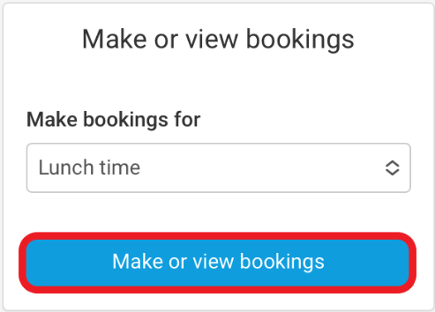
- You will then be presented with the booking screen.
- Select the date you wish to book.
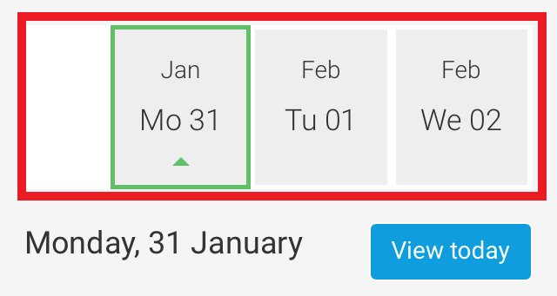
- Scroll and tap the main meal choice or place for your child (this will then be highlighted in orange).
- Tap the arrow to view Allergen or nutritional information (if available).
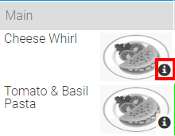 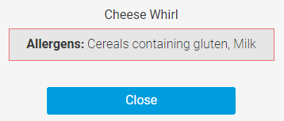
- Some menu’s may require you to select a dessert. Scroll to view dessert options and tap the desired choice.
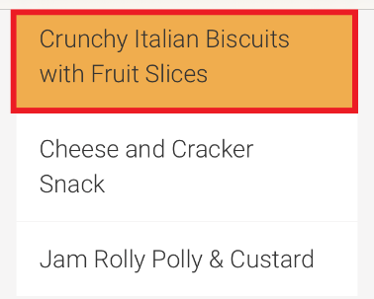
- Scroll back to the top of the screen to choose another day.
- Repeat steps 7 through to 9 until you are ready to confirm your bookings.
Note: You are able to scroll through the dates and choose meals for up to 10 weeks in advance (depending on your schools settings). You will need to select the last date that appears, to be able to see further dates.
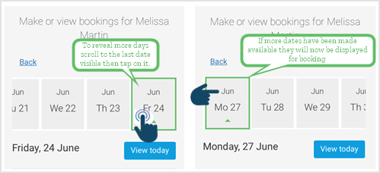
- If you pay for the bookings these will need to be paid within two hours of confirming.
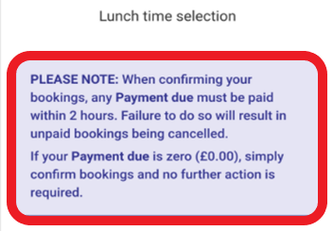 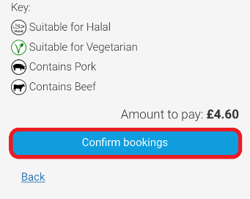
- Tap on the Confirm bookings, if payment is due you will be taken to the basket.
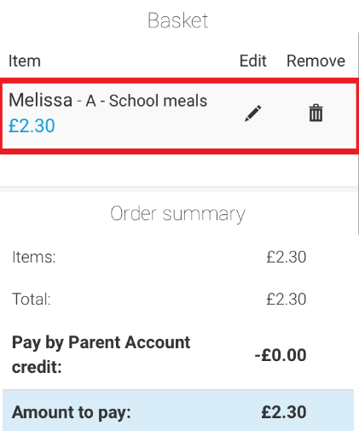
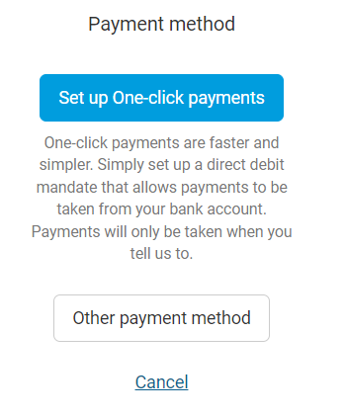
- Once you have completed your bookings return to the basket and choose the payment option that most suits you.
- Confirmation of payment will appear on your mobile device and you meal or places bookings will have been sent to the school.
