Monday 13th May 2024

L.O: To spell words by identifying sounds in them and representing the sounds with a letter or letters.

L.O: To write simple phrases and sentences that can be read by others.

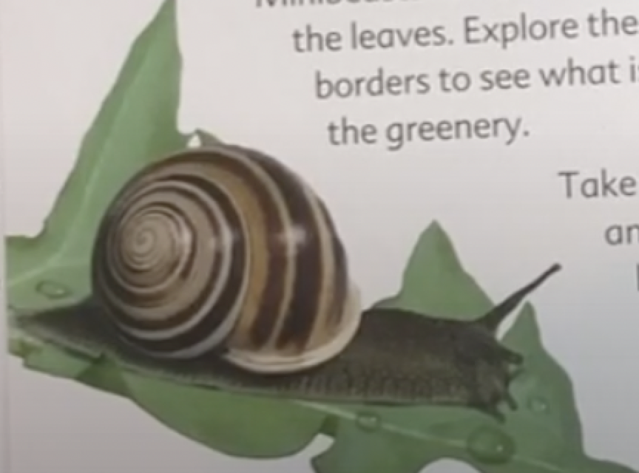

Tuesday 14th May 2024

L.O: To spell words by identifying sounds in them and representing the sounds with a letter or letters.

L.O: To write simple phrases and sentences that can be read by others.

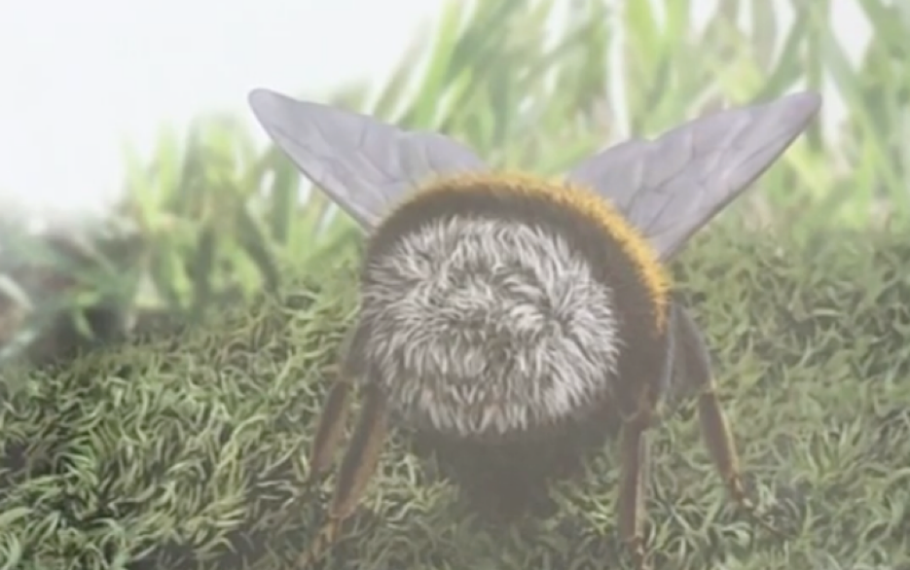

Wednesday 15th May 2024

L.O: To spell words by identifying sounds in them and representing the sounds with a letter or letters.

L.O: To write simple phrases and sentences that can be read by others.

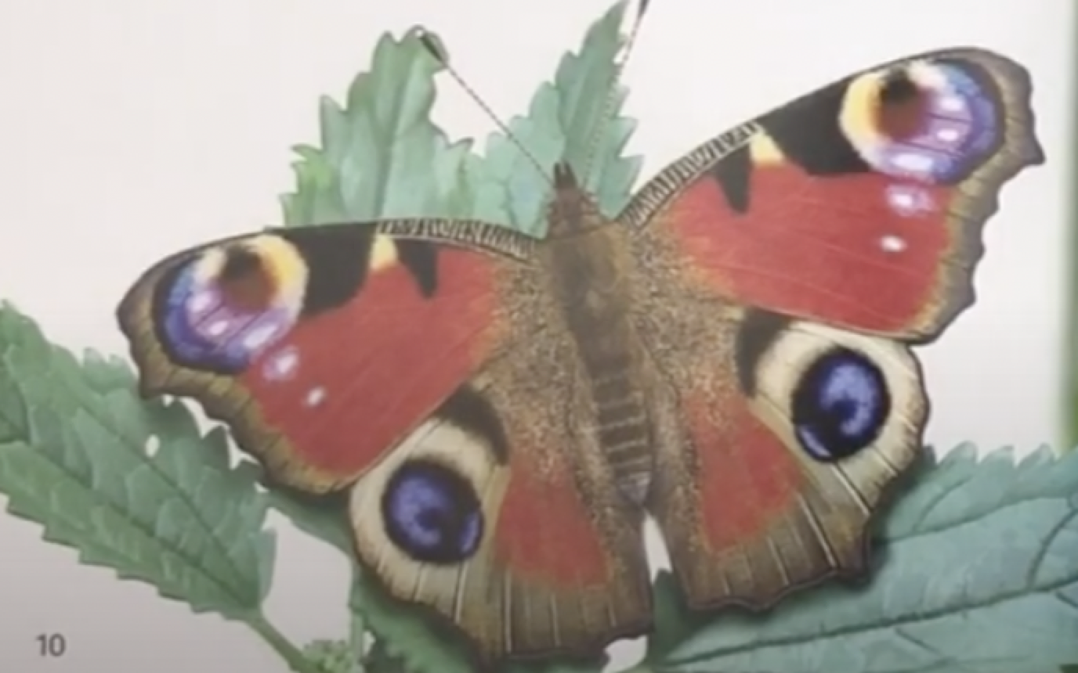

Thursday 16th May 2024

L.O: To spell words by identifying sounds in them and representing the sounds with a letter or letters.

L.O: To write simple phrases and sentences that can be read by others.

