Date:

Lesson 1 – What is the weather?

Can you label the seasons?

Spring Winter Autumn Summer

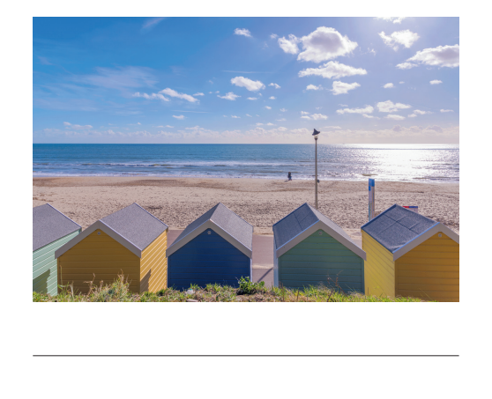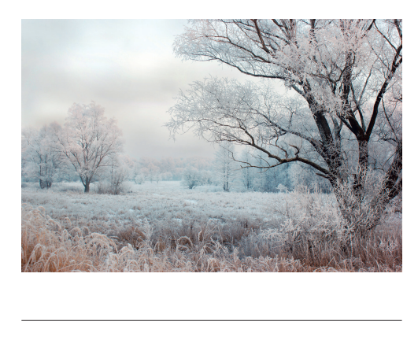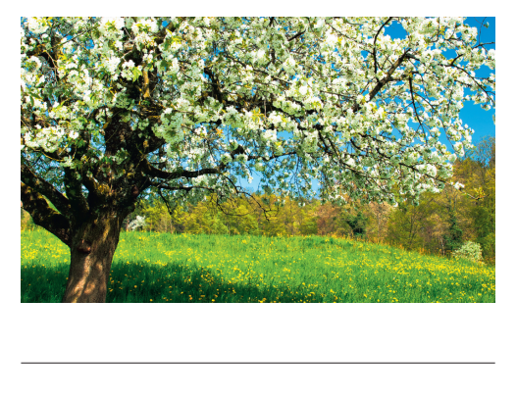 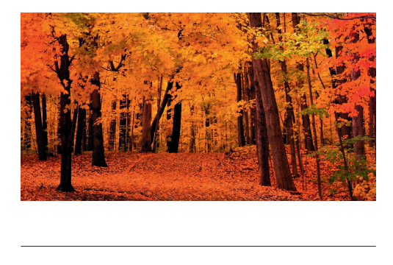

Which season do we do these activities in?

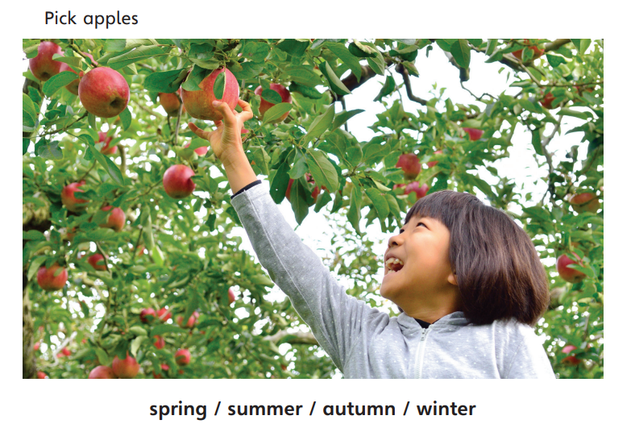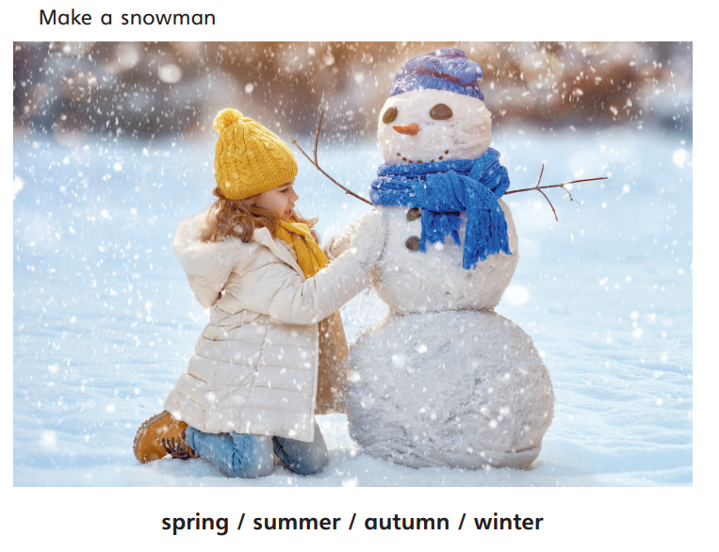

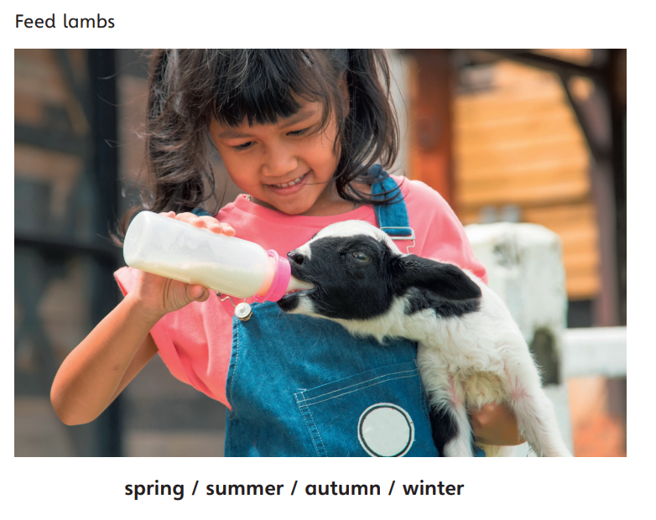

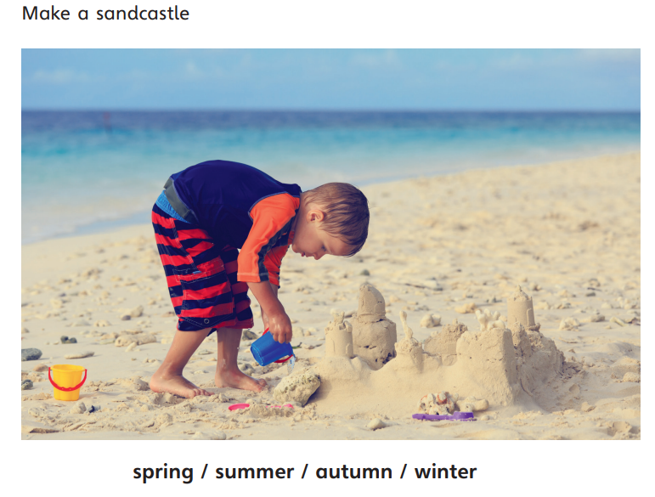

What do you like to do in each season?

In spring, I like to _________________________________________________________________________________________________________________________________________________________________________________________________________________________________

In summer, I like to _________________________________________________________________________________________________________________________________________________________________________________________________________________________________

In autumn, I like to _________________________________________________________________________________________________________________________________________________________________________________________________________________________________

In winter, I like to _________________________________________________________________________________________________________________________________________________________________________________________________________________________________