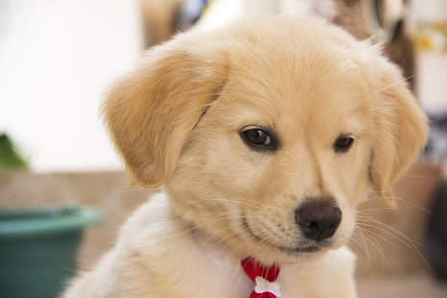

First, I wake up and climb out of my basket.

Next, I have a drink from my water bowl.

After that, I am feeling so hungry, that I eat my breakfast.