**Human Dignity-**

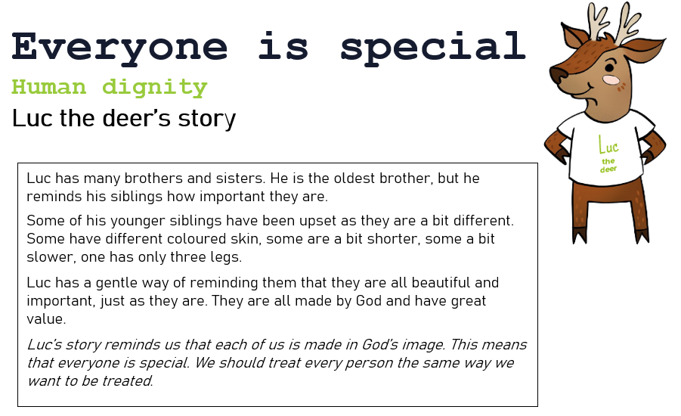

**Everyone is special**

Luc the Deer’s story: Luc has many brothers and sisters. He is the oldest brother and he always reminds his siblings just how important they are.

Some of his younger siblings have been upset because they feel that they are different to their friends. What could you tell Luc’s siblings to make them understand that they are important? I would say…