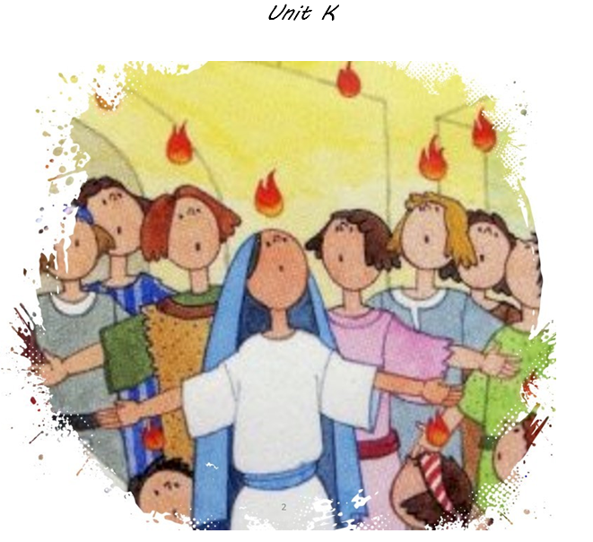

**PENTECOST**

***Key Vocabulary***

|  |  |  |  |  |  |
| --- | --- | --- | --- | --- | --- |
| **Pentecost** | **Promise** | **Holy Spirit** | **Trinity** | **Jesus** | **Disciples** |

1. **I understand that the Holy Spirit is God and that Jesus promised to send the Holy Spirit when He went back to heaven.**
2. **I know the story of Pentecost and can describe how the disciples changed after receiving the Holy Spirit.**
3. **I can identify and explain some of the symbols associated with the Holy Spirit and used in celebrations of Pentecost.**